pH Sensor tutorial

# assembling/wiring

**NOTE: Our pH sensor is wired using I2C mode, ***NOT*** UART mode. Follow the directions accordingly.** Wire the board following the directions in the documents located in the Github at: "GitHub\seeboat\tutorials\pH Sensor Tutorial\ezo-ph-wiringdiagram.pdf" and "GitHub\seeboat\tutorials\pH Sensor Tutorial\pH_EZO_Datasheet.pdf." Use the photos below to be sure you are wiring the pins correctly to the header. It helps to use the same colored wire, too.

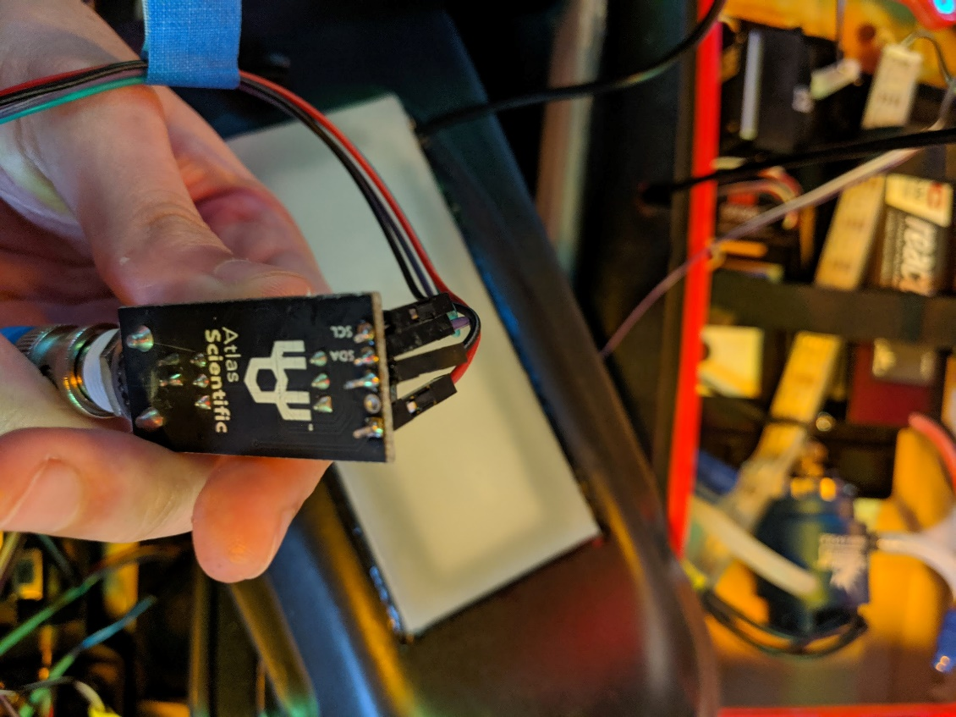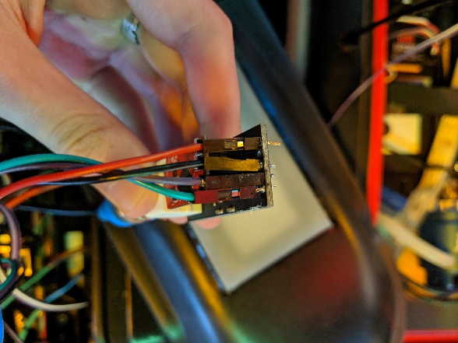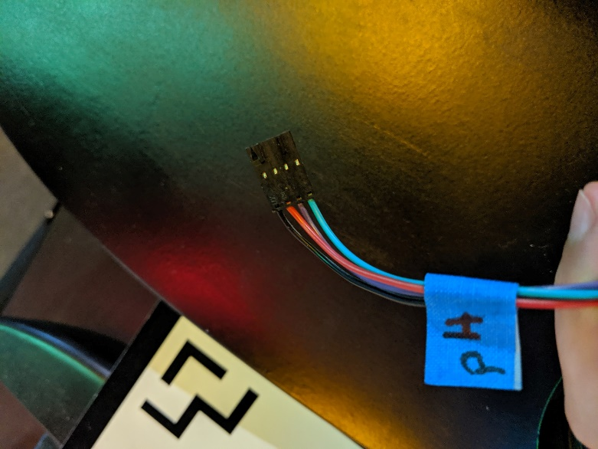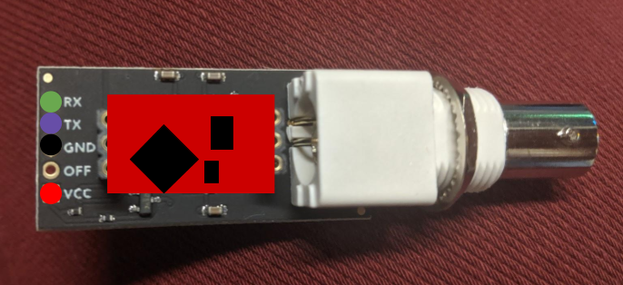

# Switching from uart to i2C

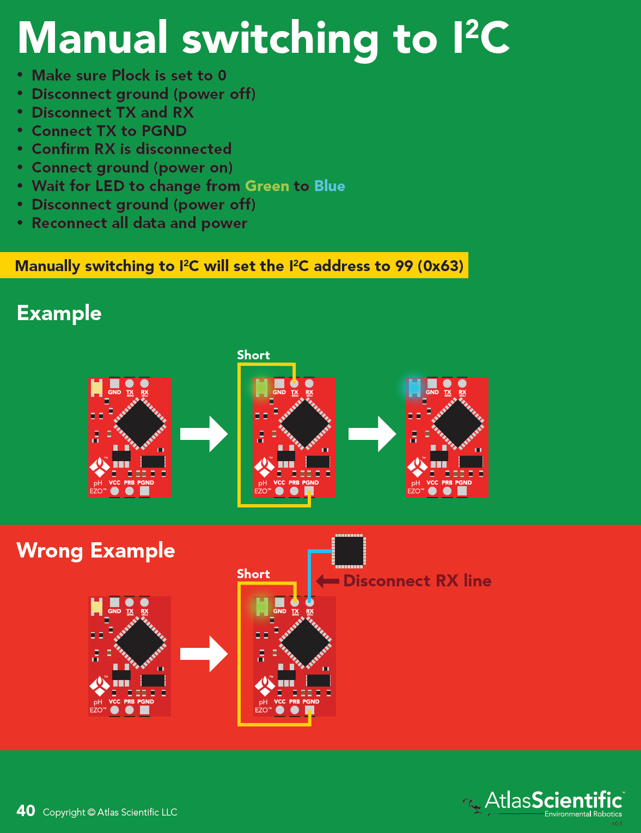

# calibrating

Follow the directions in the recalibration document if the pH sensor doesn’t seem to measuring reasonable values. The document can be found in the GitHub at: "GitHub\seeboat\tutorials\pH Sensor Tutorial\pH_reconditioning_kit_instructions.pdf."